APCSP Explore Task—Internet of Things

Concerns:

* Privacy and Security
* IoT devices do not have the processing power to thoroughly encrypt data
* They are constantly collecting data on users and users’ households, which may not be adequately protected
* Your wireless toaster can spy on you
* Also all of the IoT devices will be constantly talking to each other and evolve into Skynet

Benefits:

* Household tasks may be completed more efficiently
* You can control your toaster wirelessly!
* Also you can get a live stream of the contents of your refrigerator!
* And turn off your oven wirelessly so that you don’t burn down your house!

Statistics:

* 2017 will end with 8.38 billion IoT devices
* Which is a couple billion more than the current population of the earth
* 2020 will end with 20.4 billion IoT devices
* Which is a lot more than the current population of the earth
* 2025 will end with the Skynet takeover, judgment day, and the eradication of 95% of humanity
* And IoT will reign supreme!

Sources:

<http://www.philforhumanity.com/Internet_of_Things.html>

<https://www.toptal.com/it/are-we-creating-an-insecure-internet-of-things>

<http://www.gartner.com/newsroom/id/3598917>

<https://www.forbes.com/sites/louiscolumbus/2016/11/27/roundup-of-internet-of-things-forecasts-and-market-estimates-2016/#44a82d82292d>

For IoT Image:

<http://blog.co-star.co.uk/2016/07/05/installed-base-wireless-iot-devices-industrial-automation-reached-14-3-million-2015/>

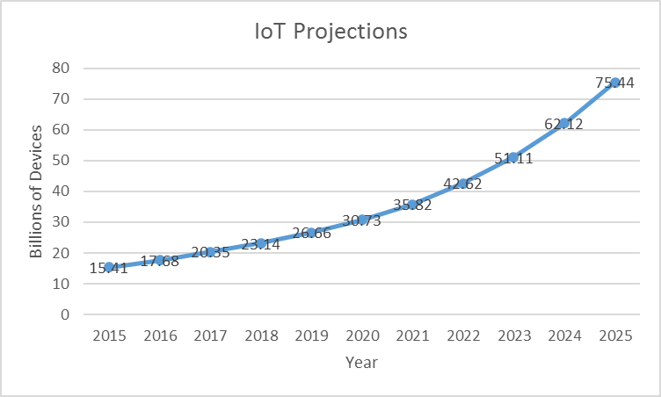

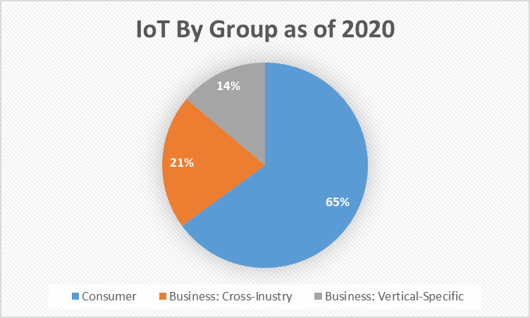

Computational Artifact Planning

Brief explanation of what IoT is and how it works

Graph of IoT projections

Written Response

2.A My computational artifact represents the computing innovation that is IoT, or the Internet of Things. The upper half of the artifact represents the IoT concept itself, which is the use of computers and sensors in everyday devices so that these devices may be connected to the internet, making them more easily and efficiently accessed and controlled by the user. The lower half consists of information that is largely statistical, such as projections of the number of IoT devices in years to come (2025 is expected to end with 75.44 billion devices) and the popularity of IoT among various types of users (65% of the users are average consumers, 21% cross-industry business, and 14% vertical-specific business).

2.B I began by using the internet for some simple research into IoT concerning its projections, history, and security concerns. After obtaining this data, I used Google Images to find images that would be suitable for my infographic, and the graphing tool in Microsoft Excel to assemble my data into usable graphs. I edited these images in GIMP 2, an image-editing program, in order to make the images aesthetically pleasing on an infographic (mainly by using the shift key and ‘fuzzy select’ tool to select regions of the image, and the ‘add transparency layer’ button and delete key to make the selected area transparent). Finally, I used an online infographic tool known as ‘easelly.’ Here, I uploaded my images, added text, and placed some stock arrows on the screen—through their simple and intuitive interface—to create an infographic.

2.C The Internet of Things has the potential to drastically increase efficiency in our society. Rather than being limited to, say, operating our appliances while in their vicinity, we control them while at work, school, or while simply out of the house. Our scheduling would be much less constrained with this decrease in limitations, and we would be able to accomplish more in smaller amounts of time. However, with the IoT projection statistics, the future of our society will be a black-hat hacker’s paradise. With 75.44 billion IoT devices by 2025, nearly all of which may be easily taken over by hackers due to the lack of security protocols, hackers will be known less as the mythical creatures that take over the Pentagon, and more as the people that take over your thermostat.

2.D IoT devices are based around the use of data. They come with massive assortments of sensors, and have the capability to transfer this data wirelessly. The data collected depends on the device; for example, a refrigerator will collect data on the temperature, its contents, etc. Any medical device would contain and collect data on the medicines taken by the user. Any device with a microphone would be constantly collecting audio data, and any device with a camera would be collecting video data. This data would be broadcasted through the internet, for the information to be received by the user. The security problem arises in the fact that IoT devices run off of underpowered processor chips in order to keep the device small and cheap. These small processor chips are not capable of thorough data encryption at a speed that is efficient, and aren’t particularly good at running multiple intensive tasks at the same time. Thus, the massive amounts of data being collected by an assortment of IoT devices are being sent, relatively unprotected, through the internet. This potential exposure of the details of human lives through inadequate computer security measures is most definitely a security concern.

2.E

<http://www.philforhumanity.com/Internet_of_Things.html>, Phil for Humanity, “The Pros and Cons of the Internet of Things,” source: Phil for Humanity, date viewed: 3/24/17, posted: 3/12/14

<https://www.toptal.com/it/are-we-creating-an-insecure-internet-of-things>, Nermin Hajdarbegovic, “Are We Creating An Insecure Internet of Things (IoT)? Security Challenges and Concerns,” source: Toptal, date viewed: 3/24/17

<http://www.gartner.com/newsroom/id/3598917>, Gartner, source: Gartner, date viewed: 3/24/17, posted: 2/7/17

<https://www.forbes.com/sites/louiscolumbus/2016/11/27/roundup-of-internet-of-things-forecasts-and-market-estimates-2016/#44a82d82292d>, Louis Columbus, “Roundup Of Internet Of Things Forecasts And Market Estimates, 2016,” source: Forbes, date viewed: 3/24/17, posted: 11/27/16

<http://www.zdnet.com/article/iot-devices-can-be-hacked-in-minuteswarn-researchers/>, Danny Palmer, “IoT devices can be hacked in minutes, warn researchers,” source: ZD Net, date viewed: 4/14/17, posted: 10/25/16